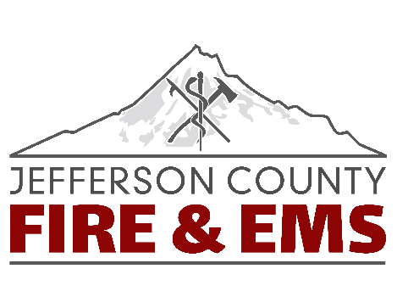
Job Description – Office Assistant
Job Summary
The Office Assistant provides organizational, technical, and analytical support to all Jefferson County Fire & EMS volunteer, shift personnel, and command staff.
The Office Assistant performs related work as required or additional duties as assigned.
Essential Job Functions
- The work is conducted with wide latitude, requiring utilization of independent judgement and initiative.
- Maintain and ensure protection of confidential information and files, including those related to labor relations, personnel records, budgets, and finances.
- Assist with new hire training, scheduling of application process, and proper personnel paperwork.
- Attends meetings, takes and transcribes minutes, prepares and distributes materials as assigned.
- Maintains a schedule of events and makes arrangements for meetings and conferences.
- Compiles budget information and prepares materials for expenditures.
- Community outreach involvement and development.
- Receives, records, and deposits money for the County Smoke Management Program.
- Research and respond to public records requests and maintain records in accordance with retention program.
- Research, compile, and analyze data for a variety of projects.
- Answer phone calls and take messages, operate all office equipment effectively, in addition to general office duties including filing, faxing, photocopying, and scanning.
- Prepare monthly accounts payable reports; assist with general bookkeeping, accounting, and budgets.
- Assist the command staff in various administrative and clerical tasks and other duties as assigned.
- Assist with grant management and procurement.
- Assist in the development of office procedures and forms.
- Ensure filing systems are maintained and up to date.
- Verify receipt of supply on all internal and external purchases, receive and process accounts payable.
- Interacts effectively, professionally, and tactfully with the general public, participating agencies, dispatch, law enforcement, and other outside agencies.
- Exercises effective communication; orally and in writing.
- Supportive role to all aspects of the administrative department.
- Filing and reporting for the Ground Emergency Medical Transport (GEMT) application.
- Ability to express ideas clearly and concisely, orally, and in writing.
Knowledge, Abilities, and Skills
Knowledge of:
- General knowledge and ability to obtain information on all Jefferson County Fire & EMS policies, operations, and protocols.
- Knowledge of all new and existing computer applications and software.
- Knowledge of basic bookkeeping, accounting principles, and practices.
- Knowledge of the GEMT application process and reporting.
Ability to:
- Ability to deal effectively with citizens and employees under stressful, emotional, and hazardous conditions.
- Ability to communicate effectively using verbal and written communications including reports, memos, correspondence, and forms.
- Ability to apply written policies and procedures in practical situations.
- Ability to develop and maintain productive working relationships across departmental and municipal lines.
- Ability to use computer software to access data, prepare documents, and develop proposals.
- Ability to maintain a high level of accuracy in preparing and entering information.
- Ability to coordinate, adapt, and manage several activities simultaneously under stressful busy conditions.
- Ability to compose effective correspondence independently, including appeals.
Skills:
- Highly skilled, operating at a proficient level of modern office practices, with emphasis on computer literacy, word processing, spreadsheet applications, company email, billing software programs, electronic records, and file management.
- Skilled in the preparation of written reports.
- Skilled in researching complex issues and developing recommended actions.
Training and/or Education
- Graduation from a standard high school or equivalent.
- Minimum Associates degree in related field preferred.
Licenses and Certifications
- Must have a current, valid Oregon driver’s license
- Maintain current CPR and Basic First Aid.
Physical Demands
The physical demands described here are representative of those which must be met by an employee to successfully perform the essential functions of this job. Reasonable accommodations may be made to enable individuals with disabilities to perform the essential functions.
While performing the duties of the job, the employee is regularly required to use their hands to handle or feel objects, use tools or controls, and reach with hands and arms. The employee will spend long hours sitting, using office equipment and computers, which can cause muscle strain. The employee is frequently required to talk and hear customers in person, on the phone or with the radio. The employee is regularly required to stand, walk, stoop, kneel, and crouch. The employee must regularly lift supplies and/or materials weighing 10 to 25 pounds.
Reports To
Jefferson County Fire and EMS, Fire Chief
Supervises
None

