
EMS NEWS

November 2025
Vol 1/Edition 8
IN THIS ISSUE
- Training
- EMS Equipment & Supplies
- SCMC-JCF&EMS Connections
- Regional & State Activities
- Community

Here’s the scoop on happenings in EMS at Jefferson County Fire & EMS

By Dep. Chief Michael DK Lepin

Training
Case Review: Always the 2nd Wednesday of the month at 1000hrs with Dr. Luke Welle, MD.
More Vent Training: Our Hamilton rep is working on putting together another training for us. The dates for that will be posted as soon as he gets back to me.
In the meantime, Capt. Glen and Paramedic Melody Ronan helped me put together some training videos for your benefit. You can find them in here: S-drive → EMS → Training & Classes → Hamilton Ventilator → Training Videos
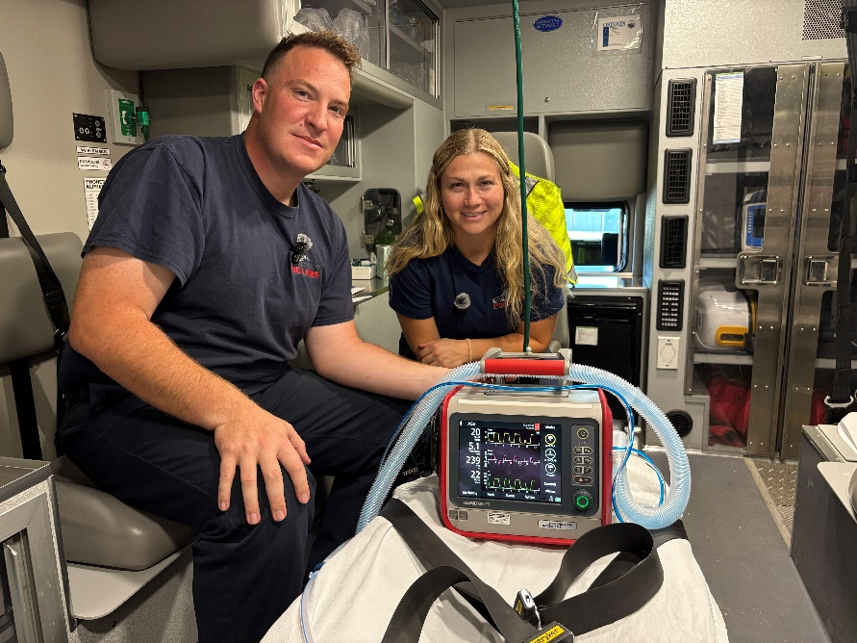
Equipment & Supplies
AED: I got a quote from ZOLL for an AED Plus, which will be placed on 1741. Unfortunately, there is a delay on these and will most likely take about 2 months to arrive.
Ativan: The Ativan we had in inventory was recalled and had to be returned. After some discussion with Dr. Welle, I decided not to replace it. Midazolam is faster-acting and appears to be more preferred by our providers. We will keep it in our protocols in case we need to find an alternate benzodiazepine.
SCMC-JCF&EMS Connections
Transfer Center: I met with Rebekah Bruce on October 15th and had a pretty good discussion. She mentioned they finally found a replacement for Daniel as their director. That person is Adrian McDugal, who moved from a different department in St. Charles. In the next few months, I’ll learn what her role will play as well as Rebekah’s in our meetings.
As mentioned before, SCMC is working on improving their “call to balloon” time, meaning getting their Heart One patients into the Cath-lab. Their Medical Director has identified that some of the delays in time are due to not activating the team when some calls come from EMS. In the past, as most of you know, once EMS activates a Heart One, they wait for assessment from the ER before fully activating the Heart One team. Rebekah said most of the time the ambulance arrives in the ER before the team could have been activated anyway, but I pointed out that’s only true in Bend. Calls coming from Jefferson County or Crook County provide ample time for calling the team. There will be more to come.
Rebekah also commented on the Tiger Connect, which was discussed at ECEMS. She said it should be rolling out in the first quarter of 2026.
Rebekah confirmed that SCMC is working on an RFP to find a company to provide inter-facility transfers, CCT, ALS, and BLS. I asked about our ‘first right of refusal’. She said that will not be affected. This RFP is to find a single provider to pick up their CCT transfers and other transfers that CCF&R, RFD, and our agency cannot do. Currently Adventure Medics and Life Flight are the two companies interested in the RFP.
SCMC-JCF&EMS: I met with Labree on October 6th. We talked about a comment she heard from some of her nurses. It had been discussed between these nurses and some medics that JCF&EMS have up to 2 hours to decide if we will take a transfer or not. I assured her that is not the case. Once we receive a request for a transfer, if we are available, we will respond to take the transfer. If for some reason we are not available, our Duty Officer will contact the Transfer Center and/or the Charge Nurse and explain why we are not available. The big key here is communication. The more we communicate the better.
Regional & State Activities
Balance Billing: The next meeting will be on November 13th.
ECEMS: East of the Cascades EMS (ECEMS) is an association of Central Oregon EMS Providers that serves to create shared treatment protocols, partnerships in training and mutual aid. Our association also gives us a bigger voice when talking with the OHA or State.
ECEMS meets quarterly and our last meeting was October 1st. At this meeting it was time to nominate next year’s officers. No one seemed excited to step up and the current officers were willing to continue their job for another year. These officers are:
President: Cody Meredith, Sisters Camp-Sherman Fire District
Vice President: JJ Johnson, Sunriver Fire & Rescue
Treasurer: Drew Norris, Bend Fire Department
Secretary: Josh Erwin, Lapine Rural Fire Protection District
The big thing we discussed was the Tiger Connect communication platform being hosted by St. Charles Medical Center. With an app on your smartphone, this platform provides the EMS provider with a communication link to the Emergency Department & Online Medical Control (OLMC). The provider can send photos and other information to the ER, and the provider can have video consultations with the OLMC Physician when needed.
Also discussed was the regional MCI plan. ECEMS will take over the responsibility of the updating process of this plan, which will be started early in the new year.
After the meeting was concluded, our Medical Director, Dr. Luke Welle, participated in the Treatment Protocol review. I’m sure there will be more to follow from that discussion.
Jefferson County ASA: Next meeting is November 18th.
Oregon Medical Board’s EMS Advisory Committee: Next meeting is November 21st.
Oregon State Ambulance Association (OSAA): Next meeting in on November 7th.
Rural EMS: I will be meeting with Joan from Oregon Rural Health and Rebeckah Berry from the Roundhouse Foundation on November 12th. Alex Carr from South Wasco County EMS and Nicole from Senator Wyden’s office will be joining us.
Wasco County ASA: Next meeting is in November.
Community
East Cascades Assisted Living: There was an incident where our crew was requested to come start an IV for a patient at East Cascade Assisted Living. The staff didn’t want us to transport the patient, just start the IV for them. This has happened in the past. This isn’t a service we should be doing.
I spoke with their director about this, and it got corrected. The positive thing that came out of it is I was able to restart our monthly check-ins. I used to meet with one of their nurses monthly, but she moved on. This reconnection will help curve issues before they get bigger.

