2021
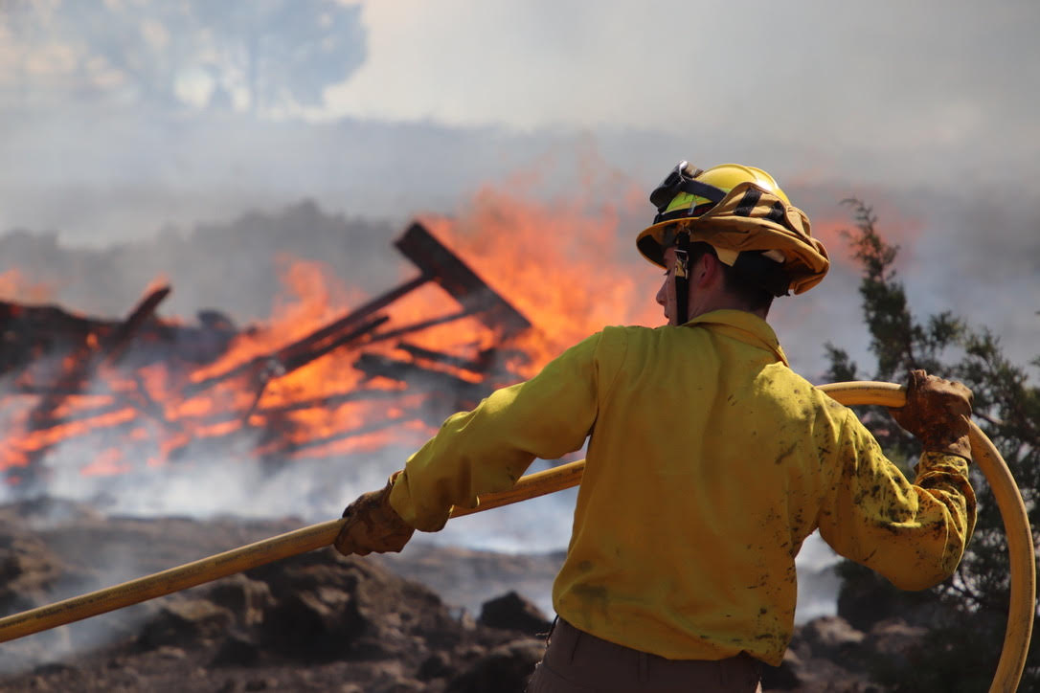
Annual Report

Jefferson County Fire District #1
765 South Fifth St.
Madras, Oregon 97741
JCFR1.org
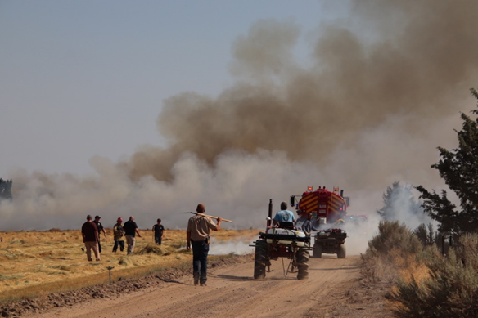
Table of Contents

2021 in Review 1 & 2

Operations & Statistics 3

Public Education Fire Prevention 4 & 5

Training Program 6 & 7

Volunteer Program 8 & 9

Student Program 10

Maintenance 11

EMS 12

District Maps 13 & 14

2021
Annual Report
Table of Contents

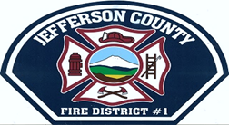

Jefferson County
Fire District #1
765 S. Fifth St.
Madras, Or. 97741

Our Mission
To protect life and property from fire, hazardous
materials, and other perils, provide necessary
basic life support services, and to preserve the
quality of life for the citizens whom we protect.
Chief’s Message

It is my pleasure to present to you the 2021 annual report for Jefferson County Fire District # 1. 2021 was a challenging and busy year for JCFD # 1. The members of this department handled it with professionalism, flexibility and dependability with service to our community and safety always a priority.
I was given the opportunity to step in as Interim Fire Chief of JCFD # 1 for the past year. This was a great experience for me as we navigated around many challenges, but we have a great team and worked through them together.
COVID: As an organization we had to navigate around Oregon Health Authority mandates associated with COVID. COVID hit many of our staff and volunteers as it did for many other fire districts and our community. Our personnel experienced illness as well as their family members. The dedication of our staff, volunteers and interns during this difficult time was inspiring. In spite of these challenges we were able to still provide uninterrupted services. We know this is going to be an ongoing challenge for our district, but our crews are up for task and will stay staff.
Increase in call volume: We finished 2021 with 1077 calls and are up from 2020. We have seen an 18% increase in call volume since 2019. The increase of call volume exemplifies the needed staff and how important our volunteers and interns are for community.
Reduced staffing: The absence of a chief position has required all of us to step up and provide additional service to the community. Staff, Volunteers and Interns stepped up during that this year responding to emergencies. In the absence of a Fire Marshal, Traci Cooper and Mark Carman assisted in Development Team meetings reviewing plans, new construction comments and new business licenses. I thank every one of you for all your support during this busy year.
Budget: This year I had the opportunity to submit my first budget and could not have done it without staff and the assistance from Jefferson County.

Chief’s Message

Grants: This past year we submitted and were successful for many grants such as;
- FEMA Public Assistance
- OSFM WUI Assistance
- VFA
- OSFM
- Haz-Mat by rail
- TC Energy
- Safety and Security
We have also applied for an AFG grant for a rescue/pumper and an SAFER Grant to hire 6 additional firefighters. These will be reviewed and we will be notified later in 2022.
New Chief: I am super excited who the Board has selected as our new fire chief. Chief Jeff Blake will start February 22, 2022. Chief Blake was working as a Battalion Chief with Bend Fire; he has many years of experience and a wealth of knowledge. I appreciate his ideas to make our future department great.
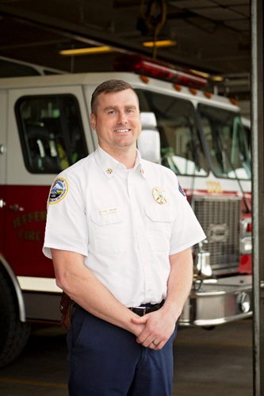
Consolidations: This year we have been moving forward with JCFD #1-JCEMS consolidation meetings. We have a group of 13 members who have a lot of knowledge and experience helping, along with SDAO and Chief Blake who have been very involved with these meetings. There are many positives moving forward, along with opportunities to grow and better serve our community. The goal is July 1, 2022 for JCFD # 1 and JCEMS to be working under an agreement, under one roof and moving forward together as one department.
As the acting chief for 2021 I am so very proud of the men and women of this district.
Operation & Statistics

2021 Total Calls: 1076
- 103- Fire Calls
- 524- Rescue & Emergency Medical Service Incident
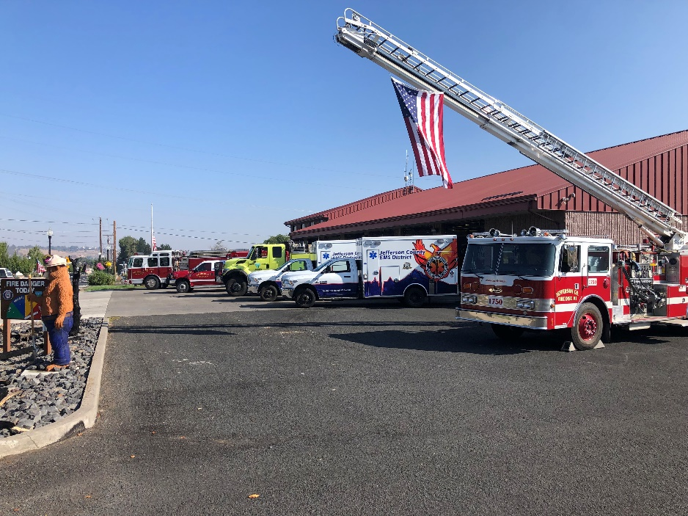
- 28- Hazardous condition/ no fire
- 115- Hazardous Condition
- 147- Service Calls
- 72- Good intent
- 88- False alarms & False calls

Madras Calls- 827
Culver Calls- 250

Hydrant Report:
133 hydrants tested
84 hydrants tested
19 new hydrants entered into active

Public Education & Fire Prevention

Fire Free Community Clean-up
Spring Event- Two weekends produced 561 loads of material (Limbs, Branches and Yard Debris) totaling 115.81 tons.
Fall Event- Two weekends produced 466 loads of material (Limbs, Branches and Yard Debris) totaling 85.2 tons which was about 8.28% increase from prior year.

Fire Code Inspections & Consultations
4 Special Firework Stand Inspections
1 Assembly
11 Business
8 Educational Schools

Juvenile Fire Setter Program
- Provided Screening and Fire Education to three youth and their families in the year 2021.
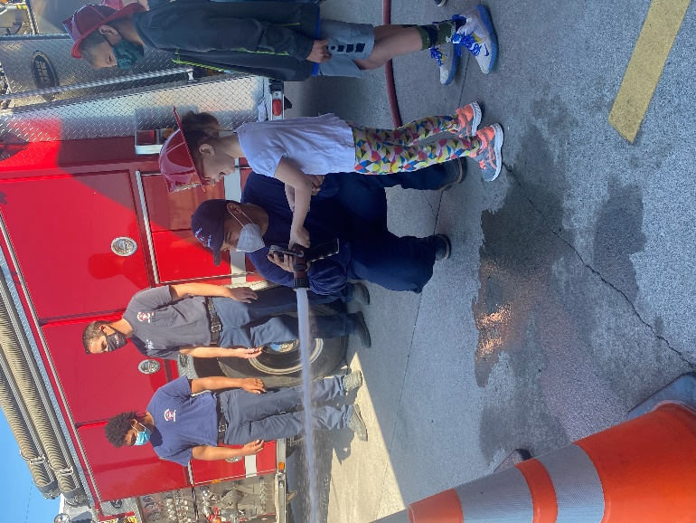
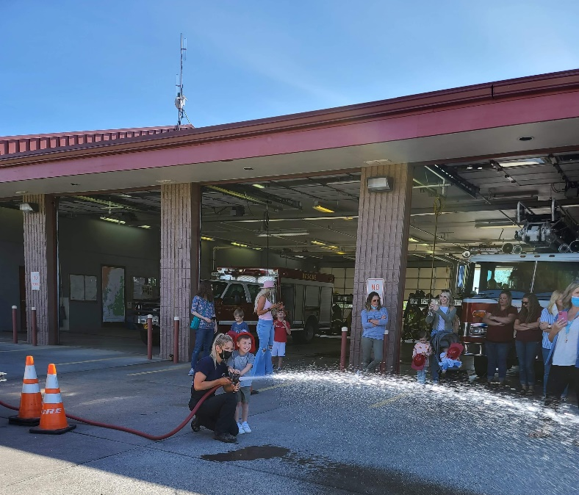

Public Education & Fire Prevention

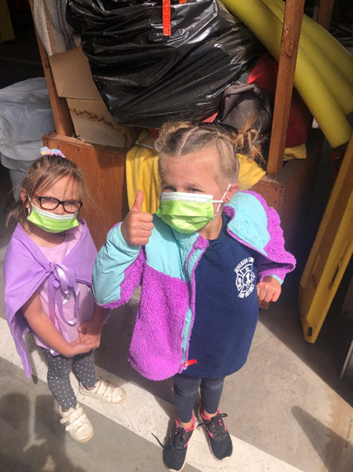
Crews installed smoke detectors in 21 residences in 2021.

Activities:
- June BBQ
- July 4th Parade
- July 4th Patrol
- Veterans Day Parade
- Christmas Light Parade
- Culver Food Basket Drive
- POW/ MIA Memorial HWY Ride Parade
- Air Show Standby
- First Thursday Fundraiser
- Jefferson County Fair Booth
- School Tours

With the 2021, being yet again, a hectic year full of unknowns, we as a department are so grateful to be able to be out in our community enjoying these activities. Seeing our community brings smiles to our faces. We look forward to the upcoming year in hopes to attend more community events and spread fire prevention knowledge.

Training Program

It is the goal of the training program to ensure all personnel are adequately trained to safely and efficiently complete duties that may be assigned and to meet or exceed all national, state, and local mandated training requirements.

To accomplish this in 2021, in-house training sessions were offered three times a week plus some weekends. Some of our personnel were able to participate in training at other locations. Online training continued to prove itself as a valuable tool during the COVID pandemic. Some topics this year included structural and wildland firefighting, emergency medicine, technical rescue, hazardous materials response, emergency vehicle operation, and ARFF.

The Department of Public Safety Standards and Training (DPSST) implements minimum standards for fire service personnel and certify qualified personnel. In 2021, we registered 16 new personnel and resigned 19 personnel with DPSST. We average a turnover of 14 people every year.

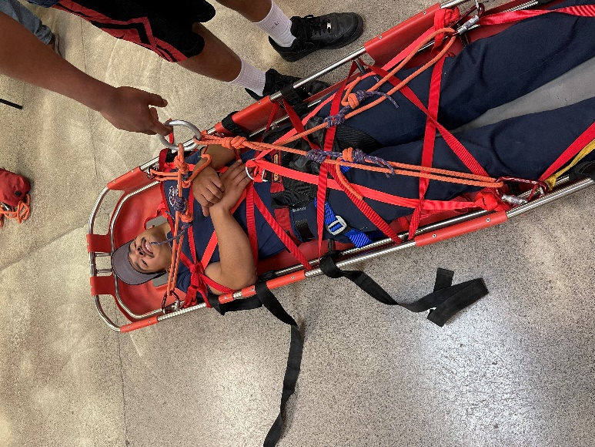
Our personnel dedicate numerous hours to training. In 2021, we documented 3912 hours of training.

Number of certifications received through DPSST:

• Driver 4
• Pumper Operator 1
• Mobile Water Supply Operator 1

Training Program

• Firefighter I 2
• Wildland Firefighter Type 2 6
• Wildland Firefighter Type 1 2
• HAZMAT Awareness/OPS 3
• Fire Instructor I 1

Academies held at JCFD this year include:
• Firefighter I
• HazMat Awareness and Operations
• Driver
• Pumper Operator
• Mobile Water Supply Apparatus Operator
• ARFF for Structural Firefighters

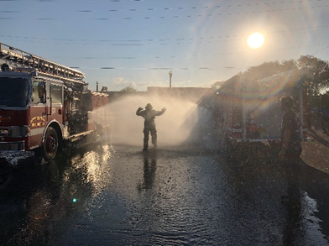
Our volunteers continue to show their dedication to the fire district and the people they serve through continued willingness to practice and improve their emergency response skills.

Mark Johnson
Training Captain
Volunteer Program

The volunteer program is an essential part of the daily operations at Jefferson County Fire #1. The volunteers are positively the heart and soul of the station. We commend them for spending hours upon hours training and risking it all to protect our community. The staff cherish them for spending so much of their valuable time serving others.

We provide a variety of positions to our interested volunteers: Firefighting (Structural and/or Wildland), Medical (Basic Life Support), Hazmat, Technical Rescue (Confined Space, Rope and Water), Incident Support and Fire Prevention/Public Education. Our Mission is to “Protect life and property from fire, hazardous materials, and other perils, provide necessary basic life support services, and to preserve the quality of life for the citizens whom we protect.”

In addition, we also offer a Junior Volunteer program available for High School students between the ages of 16 and 18. During their time in the program they are trained and help support the emergency scene until they turn 18 at which time, they are eligible to turn their training and experience into certifications.
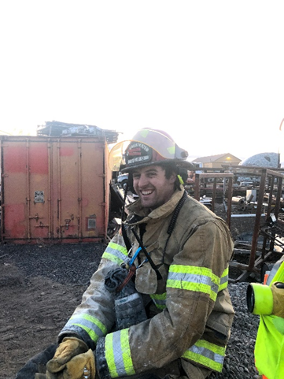
In 2021 we began with a roster of 40 volunteers and ended the roster with 39 volunteers. The breakdown of the roster is as follows:
- 24 In District Volunteers
  - 5 of these are shift firefighters for
neighboring fire/EMS agencies.
- 5 Out of district
- 0 Juniors
- 5 Associates
- 5 Student Interns
Volunteer Program

After a few years of unpredicted times and being unable to host an Awards Banquet we are more than excited to celebrate the efforts of our volunteers at the 2021 Awards banquet. From “rookie of the year” to the individuals who ran the most calls between not only the Madras station but Culvers Station as well to Fire fighter of the year and everything in between. We can’t thank our volunteers enough!

It was once again another busy year, with training and responding to many emergencies. We responded to many fires in and out of the district, spending hours away from our families and daily lives. Our volunteers are such a valuable part of the fire station and community. Their selflessness speaks volumes about the individuals they are. We are so lucky to call them not only friends but family, we, once again, thank you for all you do.

Kasey Skaar
Deputy Chief
Volunteer Recruitment
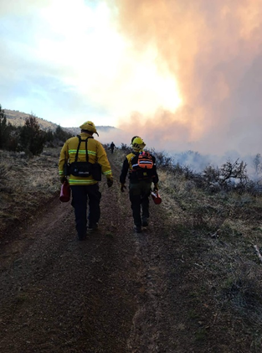
& Retention Officer
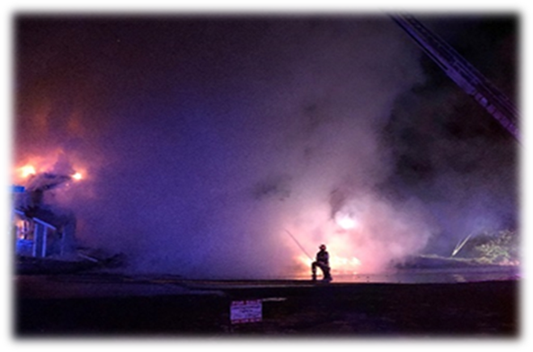

Student Program

Jefferson County Fire District #1’s student program provides selected applicants with training, on-the-job experience, tuition reimbursement, and residence at our fire stations.

Firefighter Carlson completed his two-year program in June. He has since been hired by a fire department in northern Washington. Two students resigned early from the program this year. Firefighter Buck resigned in January and Firefighter Coleman resigned in November.

Two students were selected as part of the COCC joint recruitment process. Firefighter Kearney, from West Linn, and Firefighter Malone, from Sandy, were added to our team in July. Along with our other students, they have enrolled in school as full-time students and are participating in training and emergency response as part of our educational program.

Our students continue to add a special dynamic to our district. We enjoy teaching them and watching them develop into quality emergency responders.
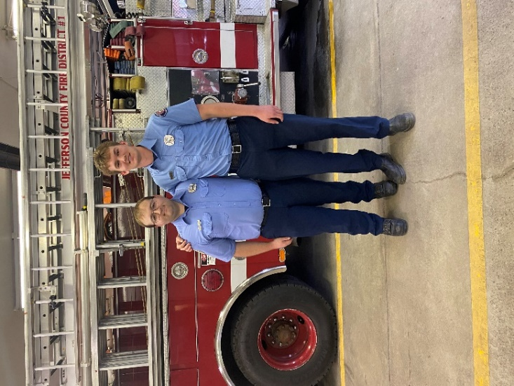
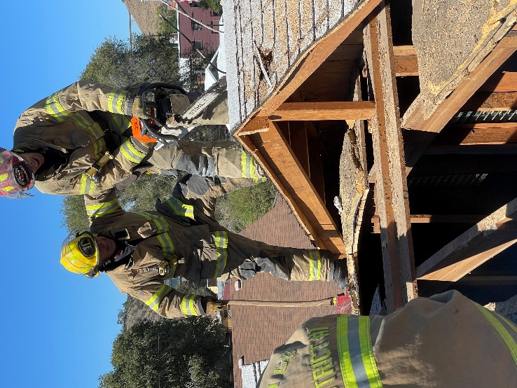
Mark Johnson
Training Captain

Maintenance Report

Maintaining a fleet of apparatus with an average age of 21 years (Fire Apparatus) and 14 years (Utility vehicles), continues to be a challenge to ensure that each are ready and able to perform as the need arises.

It is a goal of the Maintenance Department to monitor and maintain the Facilities, with 32 yrs. of age, to serve the needs of the Staff and the Public and to ensure use for many years to come.

Some highlights for the year 2021:

- Major projects on the Facility were at a minimum for 2021.
We were able to plan and complete a lighting improvement project for the Training Grounds area. The original high-pressure sodium light fixtures on the hose tower were removed and replaced with more efficient and effective LED light fixtures. This project met the criteria for a Safety and Security Grant offered by our insurance carrier, SDAO. This was a 50% matching grant.
- Our Apparatus inventory remained status quo from the year 2020 with the only change being one year older with additional mileage and hours of use.
As reported in the 2020 annual report a mobile air unit was acquired from Portland Fire Bureau, this unit became a useful addition last year as well as this year. The breathing air compressor which is used to provide air for filling our SCBA (Self-Contained Breathing Apparatus) which was purchased in February of 2004 experienced an electrical component failure. Due to the age of the compressor this component is not readily available so that changed our operation. Having the availability of this mobile unit we were able to satisfy the need for breathing air with no real issues.
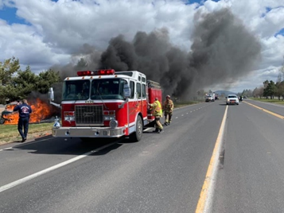
Special thanks go out to all of our volunteers and staff for their time and effort in helping to keep apparatus and equipment maintained and operational around the fire stations.

Tom Jaca
Support Services Captain
EMS Report

JCFD#1 has continued in its mission to provide basic life support services to the patrons of the district.
To meet this mission there has been training twice a month on a wide range of required continuing education (CE). In addition, American Heart Association CPR training is provided for the members of JCFD #1.
We have been doing joint training with JCEMS on the third Thursday of every month. These trainings alternate each month between fire and medical training. This training is helping both departments to better understand each other’s knowledge, tactics, and personnel.

For 2021 JCFD #1 has
• 30 AHA CPR card holders
• 3 Emergency Medical Responders (EMR)
• 13 Emergency Medical Technicians (EMT)
• 1 Advanced Medical Technician (AMR)
• 8 Paramedics (EMT-P)

